Chapter 10, Problem 56.

For each of the circuits in Fig. 10.99, obtain Thevenin and Norton equivalent circuits at terminals a-b.
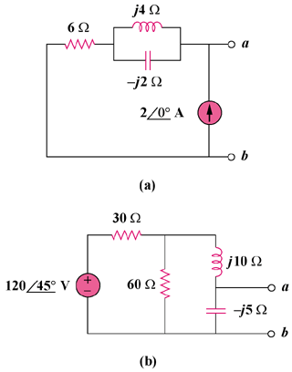

Figure 10.99
For Prob. 10.56.

